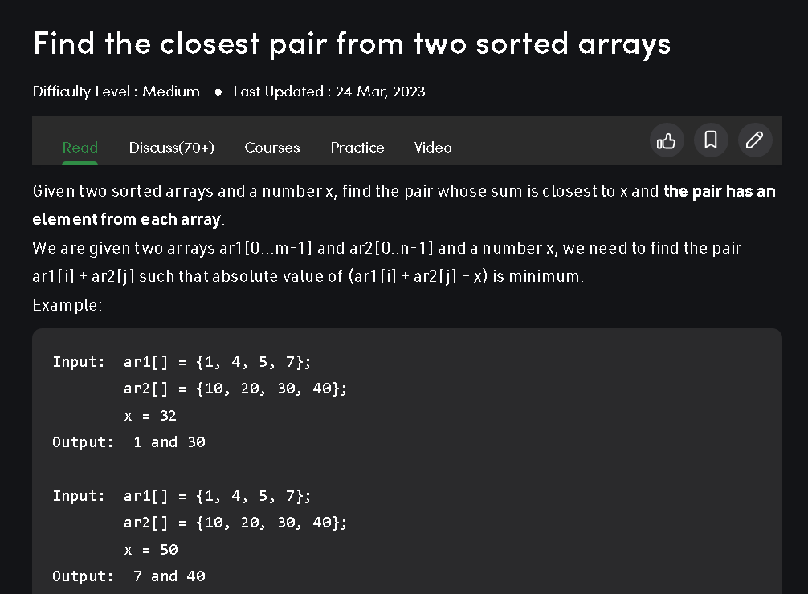

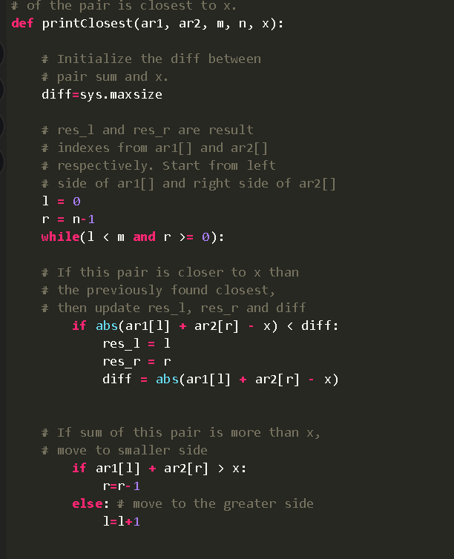

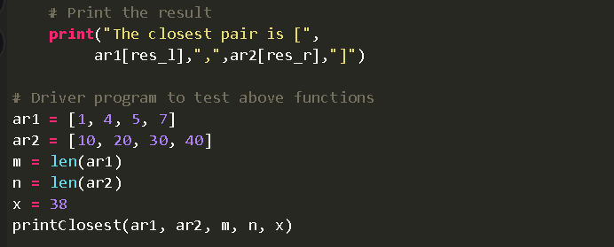

Problem link:

<https://leetcode.com/problems/squares-of-a-sorted-array/description/>

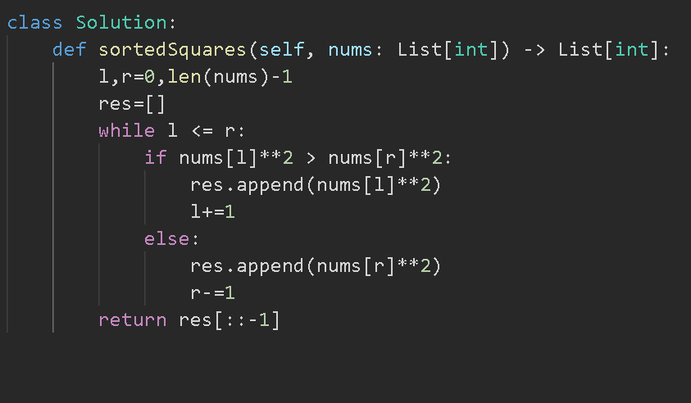

Problem link:

[https://www.geeksforgeeks.org/longest-subarray](https://www.geeksforgeeks.org/longest-subarray-sum-elements-atmost-k/)

[-sum-elements-atmost-k/](https://www.geeksforgeeks.org/longest-subarray-sum-elements-atmost-k/)

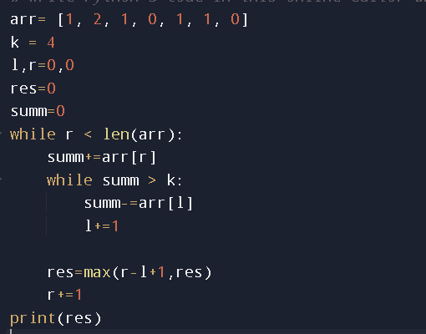

Problem link:

<https://www.geeksforgeeks.org/number-subarrays-sum-less-k/>

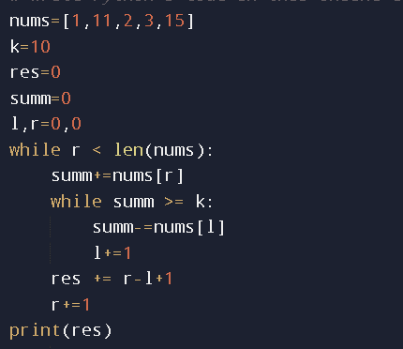

Similar problem link:

<https://leetcode.com/problems/subarray-product-less-than-k/description/>

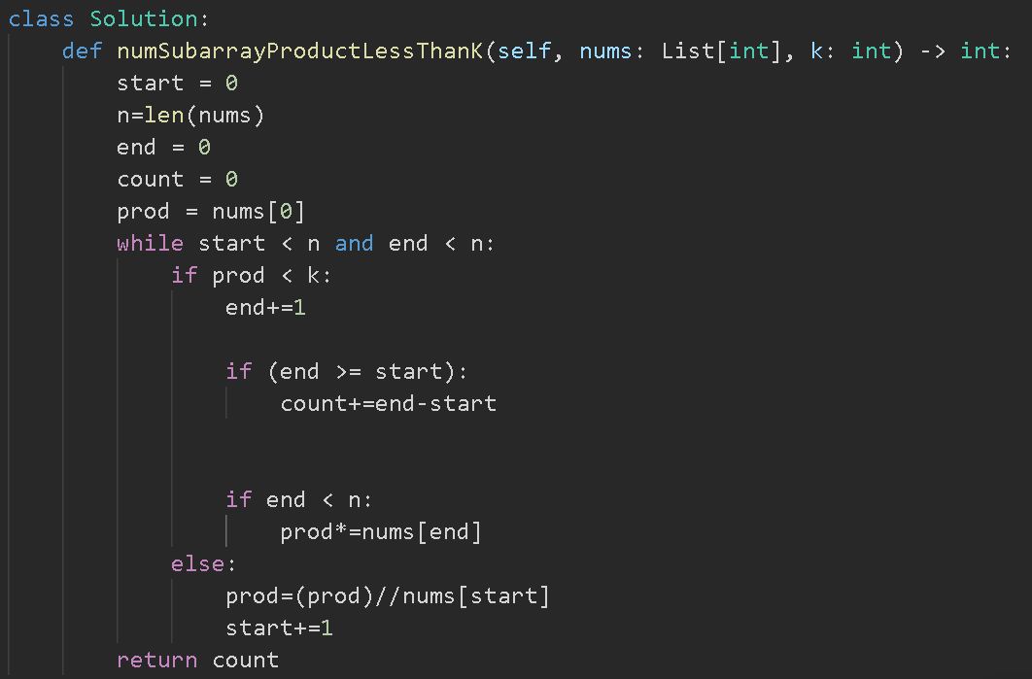

Problem link:

<https://www.geeksforgeeks.org/count-pairs-array-whose-sum-less-x/>

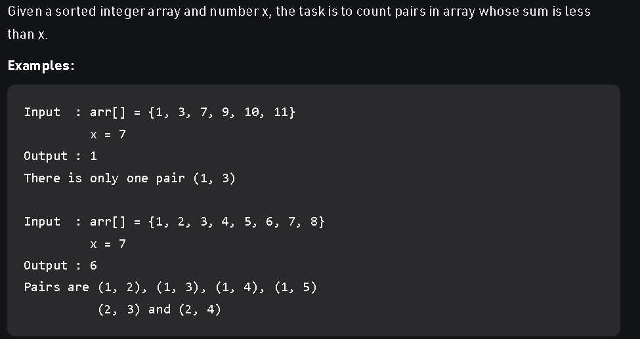

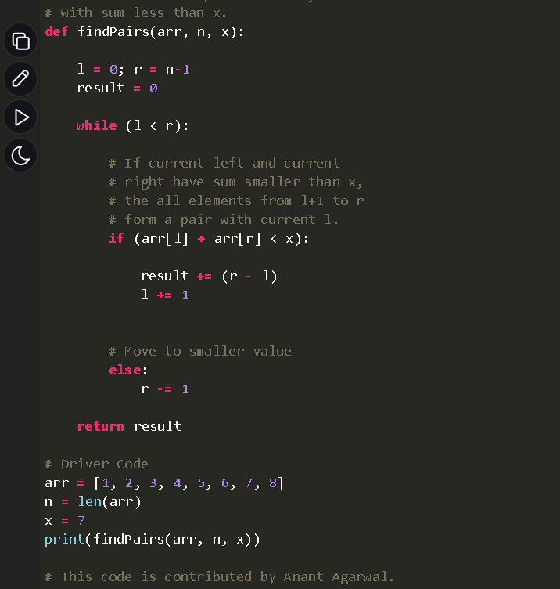

Result = result + r -l

R – L because if a pair is possible with R then all the elements before R is also eligible pair because the array is in ascending order.

Problem link:

<https://leetcode.com/problems/find-consecutive-integers-from-a-data-stream/description/>

reference video to understand question:

<https://youtu.be/XzQSm9H4TBY>

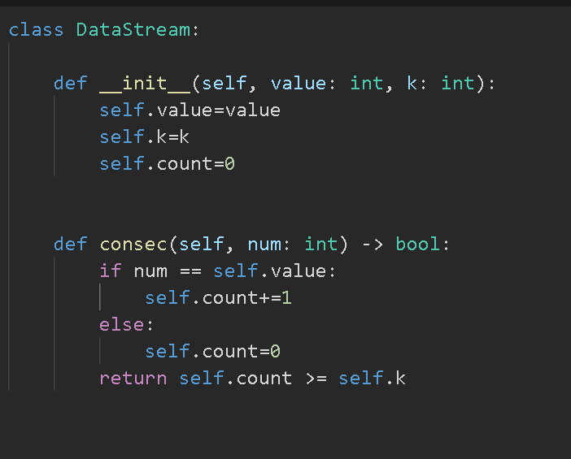

Problem link:

<https://leetcode.com/problems/remove-duplicates-from-sorted-array/description/>

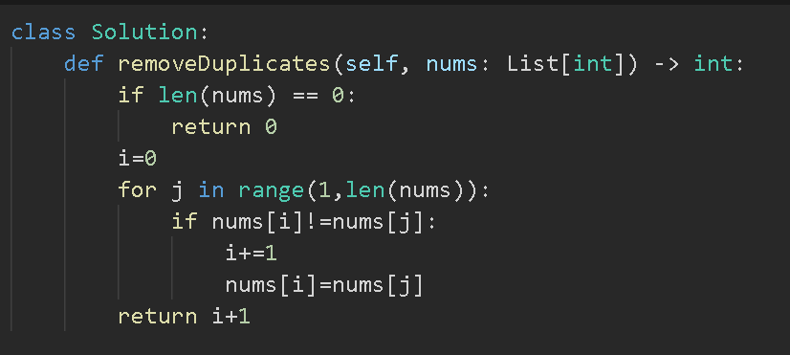

Problem link:

<https://www.geeksforgeeks.org/find-triplet-sum-two-equals-third-element/>

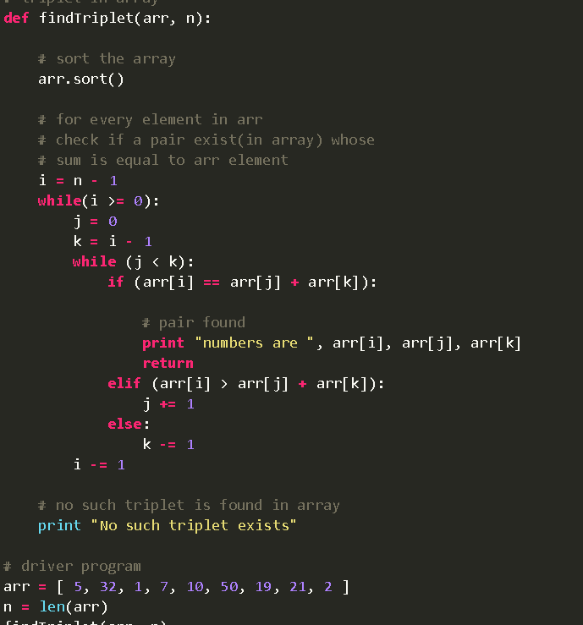

This question is similar to 3sum

***********************************************

Problem link:

<https://leetcode.com/problems/minimum-size-subarray-sum/submissions/931006800/>

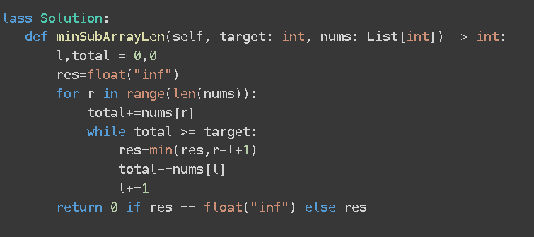

Problem link:

<https://leetcode.com/problems/number-of-substrings-containing-all-three-characters/description/>

We are using left pointer to keep track of substrings because we cannot use right pointer as it is in the loop(doing the job of calculating frequency of characters)

Problem link:

<https://www.geeksforgeeks.org/count-number-of-substrings-having-at-least-k-distinct-characters/>

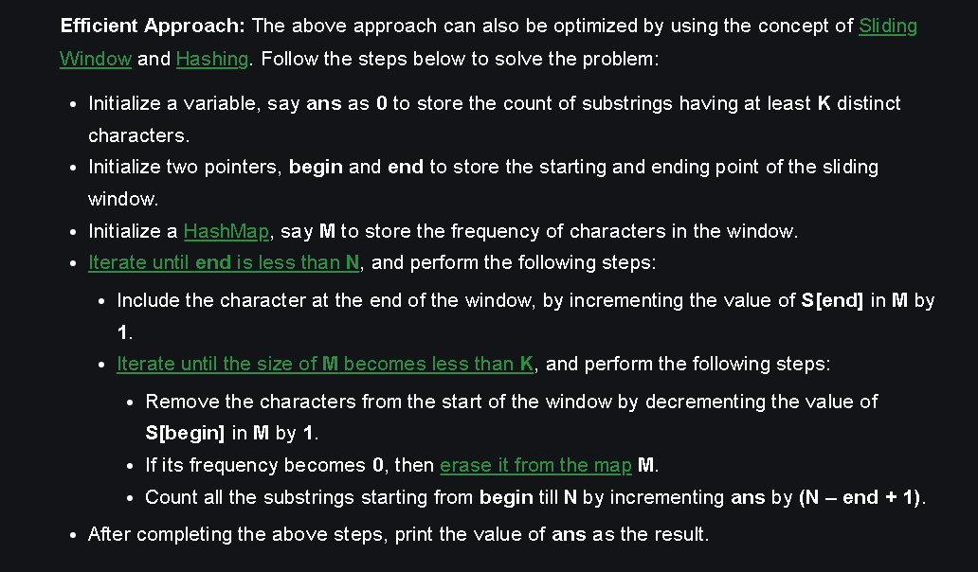

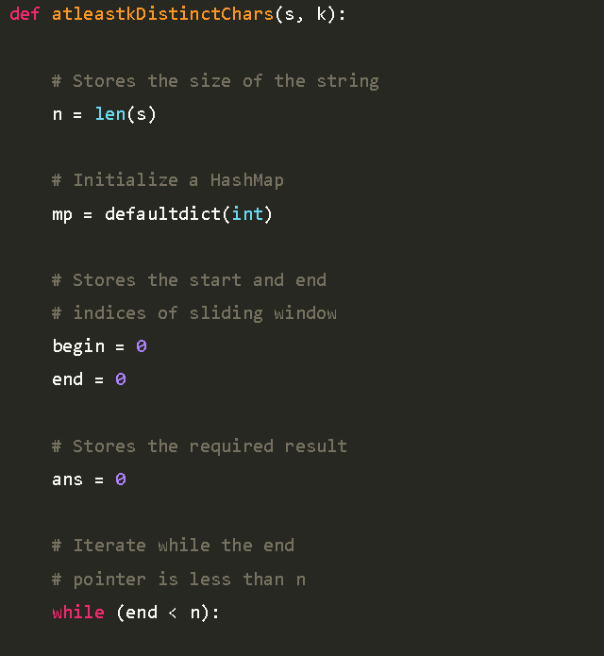

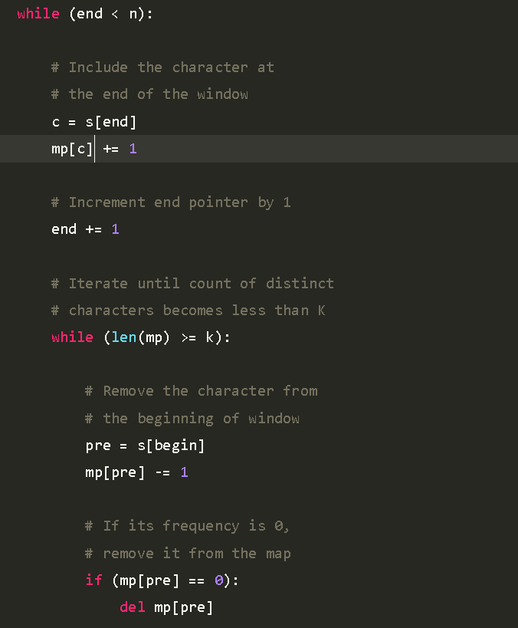

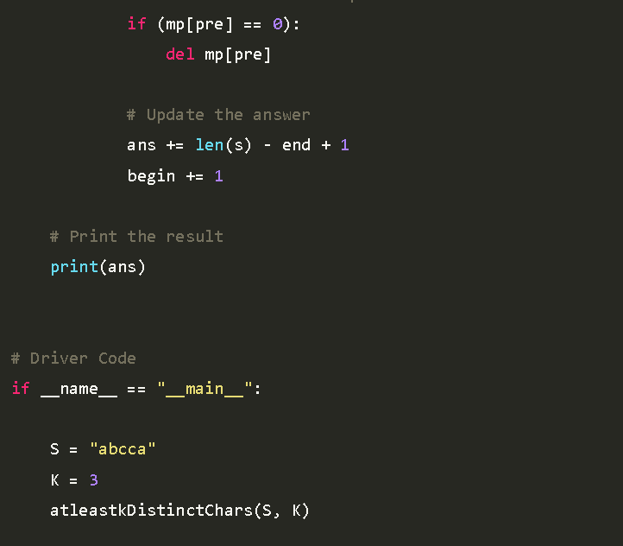

If mp[pre]==0 then Del mp[pre] because we want to reduce the size of mp as there are no more k distinct elements

ans += len(s) - end + 1 because (see the notes of previous problem in my note)

‘abcca’ -🡪 abc represents + 1

(abcc and abbcca) 🡪 represents len(s) – end

Problem link:

<https://leetcode.com/problems/longest-substring-without-repeating-characters/submissions/932664951/>

striver code:

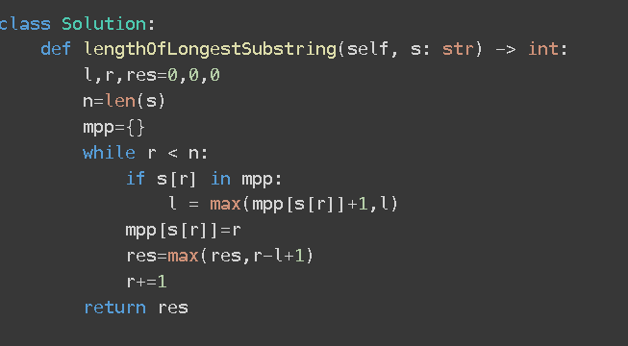

Neetcode code:

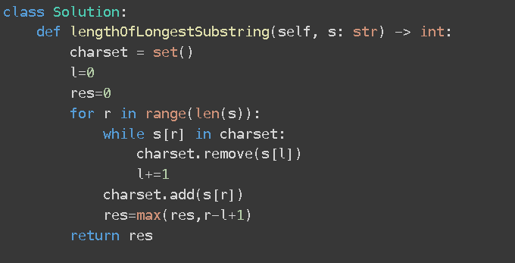

Longest substring with k unique integers:

<https://practice.geeksforgeeks.org/problems/longest-k-unique-characters-substring0853/1>

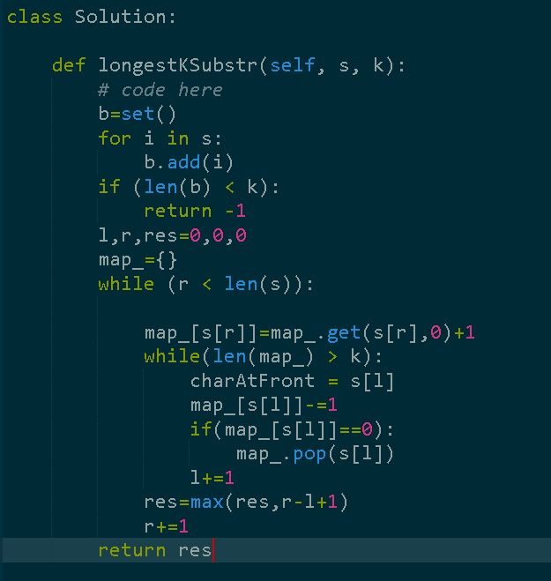

The first few lines (using set) is to handle the edge case below

Video explanation:

<https://youtu.be/k--bSleyD4E>

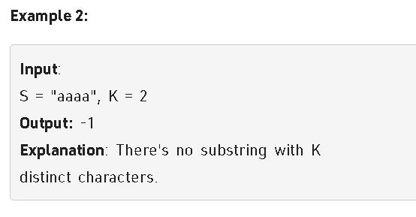

Longest substring with atmost k integers:

<https://www.codingninjas.com/codestudio/problems/distinct-characters_2221410?leftPanelTab=0>

